System and Software Architecture Description (SSAD)

Student Scheduling System

Team #10

Bo Wang: Project Manager / Quality Focal Point / Implementation Team
Bohan Zheng: Prototyper / Builder / Implementation Team
Chenyang Bai: Feasibility Analyst / Operational Concept Engineer / NDI NCS Evaluator / Implementation Team
Frank Varela: IIV&V / Shaper / Quality Focal Point
Rui Tong: Requirements Engineer / Operational Concept Engineer / NDI / NCS Acquirer / Implementation Team
Shuai Wang: System/Software Architect / UML Modeler / Implementation Team
Xiaoran Li: Life Cycle Planner / Tester / Implementation Team

Version History
Date | Author | Version | Changes made | Rationale
4/5/2014 | Rui Tong | 1.0 | Document created.  Filled in sections 1, 2.1.1 – 2.1.4, 4.1.3 | Created initial version of the document.
10/22/2013 | Rui Tong | 1.1 | Updated both the figure and the table directory
12/01/2013 | Rui Tong  Bo Wang | 2.0 | Filled in sections 2.1.2, 4  Updated use case diagram | Class diagram, sequence diagram and deployment diagram added
12/06/2013 | Rui Tong  Bo Wang | 3.0 | Filled up all the sections  Updated design rationale  Added hardware and software component diagram | Final version for DCR phase
01/21/2013 | Rui Tong | 3.1 | Updated backend class diagram, frontend class diagram, software component diagram and entity relationship diagram according to the change on database (semester entity deleted) which was raised up during the meeting on 01/20/2013 | Changes are basically based on the change of database.
04/04/2013 | Rui Tong | 4.0 | Updated Entity relationship diagram, Deployment diagram and Software Component Diagram according to instructor’s feedback | Changes are basically based on instructor’s feedback

Table of Contents
System and Software Architecture Description (SSAD) 1
Version History 2
Table of Contents 3
Table of Tables 4
Table of Figures 6
1. Introduction 7
1.1 Purpose of the SSAD 7
1.2 Status of the SSAD 7
2. System Analysis 8
2.1 System Analysis Overview 8
2.1.1 System Context 8
2.1.2 Artifacts and Information 9
2.1.3 Behavior 11
2.1.3.1 Authentication 11
2.1.3.2 User management 13
2.1.3.3 Study plan construction 16
2.1.3.4 Entering and modification of the degree requirements 17
2.1.4 Modes of Operation 23
2.2 System Analysis Rationale 23
3. Technology-Independent Model 25
4. Technology-Specific System Design 26
4.1 Design Overview 26
4.1.1 System Structure 26
4.1.2 Design Classes 30
4.1.2.1 Frontend class Diagram 30
4.1.2.2 Backend class diagram 32
4.1.3 Process Realization 34
4.2 Design Rationale 36

Table of Tables
Table 1: Actors Summary 8
Table 2 Artifacts and Information Summary 9
Table 3: Process Description 11
Table 4: Typical Course of Action 12
Table 5: Exceptional Course of Action 12
Table 6: Process Description 12
Table 7: Typical Course of Action 13
Table 8: Process Description 13
Table 9: Typical Course of Action 13
Table 10: Exceptional Course of Action 14
Table 11: Process Description 14
Table 12: Typical Course of Action 14
Table 13: Exceptional Course of Action 15
Table 14: Process Description 15
Table 15: Typical Course of Action 15
Table 16: Exceptional Course of Action 15
Table 17: Process Description 16
Table 18: Typical Course of Action 17
Table 19: Alternate Course of Action 17
Table 20: Process Description 18
Table 21: Typical Course of Action 18
Table 22: Exceptional Course of Action 19
Table 23: Process Description 19
Table 24: Typical Course of Action 19
Table 25: Exceptional Course of Action 20
Table 26: Process Description 20
Table 27: Typical Course of Action 20
Table 28: Exceptional Course of Action 21
Table 29: Process Description 21
Table 30: Typical Course of Action 21
Table 31: Exceptional Course of Action 22
Table 32: Process Description 22
Table 33: Typical Course of Action 22
Table 34: Exceptional Course of Action 22
Table 35: Process Description 23
Table 36: Typical Course of Action 23
Table 37: Exceptional Course of Action 23
Table 38: Hardware Component Description 28
Table 39: Software Component Description 29
Table 40: Front End Classes Description 31
Table 41: Backend Class Description 32

Table of Figures
Figure 1: System Context Diagram 8
Figure 2 Artifacts and Information Diagram 9
Figure 3: Process Diagram 11
Figure 4: Hardware Component Class Diagram 26
Figure 5: Software Component Class Diagram 27
Figure 6: Deployment Diagram 28
Figure 7: Frontend Class Diagram 30
Figure 8: Backend Class Diagram` 32
Figure 9: Select Desired Course Sequence Diagram 34
Figure 10: Assign Courses to Semesters Sequence Diagram 35

Introduction

Purpose of the SSAD

The purpose of the SSAD is to document the results of the object-oriented analysis and design (OOA&D) of the Student Scheduling System. The SSAD is used by the builder (programmer/developer) as reference to the system architecture. The Student Scheduling System should be faithful to the architecture specified in this document. Furthermore, the SSAD is used by the maintainer and clients to help understand the structure of the system once the proposed system is delivered.

Status of the SSAD
This is SSAD – version 2.0 for draft DC package. Section 1 and section 2 are completed.

System Analysis

System Analysis Overview
The purpose of the Student Scheduling System is to so save students’ and advisers’ time spent on constructing study plan at Stevens University of Technology. The system is intended to achieve goal though automation of study plan construction. Course directors enter information in the system about the courses and degree requirements for each of three degrees (CS, SyS, IS) offered at Stevens department of Computer Science. After that students are able to enter their requirements for the study plan in the system such as desired year of graduation, preferred elective courses, and transfer credits; the system makes attempt to construct study plan satisfying these requirements. If it is not possible to find schedule satisfying the requirements the system suggests the student to relax constrains for the study plan and repeat attempt to construct the study plan.

System Context
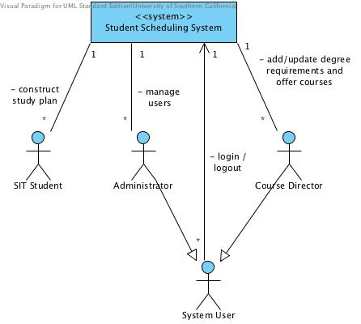
Figure 1: System Context Diagram
Table 1: Actors Summary
Actor | Description | Responsibilities
System User | Any user of the system including course director and administrator | - Log in / log out
SIT Student | Stevens’ students that use the system to construct study plan. | - Enter constraints for the study plan (year of graduation, electives, and so on) and request the system to construct the study plan.
Course director | Stevens’ faculty staff who is responsible for adding and updating available courses and degree requirements. | - Add and/or update available courses and degree requirements.
System administrator | Stevens’ staff who is responsible for adding, deleting, and updating user profile (accounts). | - Add, delete, and update user profile.

Artifacts and Information
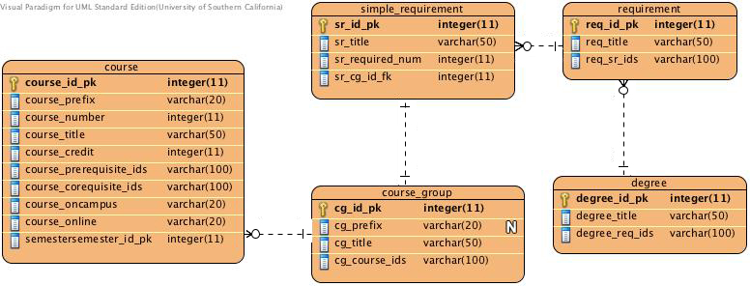
Figure 2 Artifacts and Information Diagram
Table 2 Artifacts and Information Summary
Artifact | Purpose
Semester | Contains description of the semester and its name (Fall2013, Spring2014…). These semesters are used to specify in which course is available.
Course | Contains description of the course and its attributes such as number of credits, title, prefix (CS, HUM, …), on campus or on line and its prerequisites and corequisites. These courses are used to specify course group (such as preferred electives).
Course Group | Contains description of the course group and its attributes such as title and the courses included. These course groups are used to specify simple requirement.
Simple Requirement | Contains description of the simple requirement and its attributes such as title and the course groups included. These simple requirements are used to specify requirement.
Requirement | Represents a constraint for the study plan satisfying the  requirements of a particular degree.
Degree | Contains general information about the degree (such as name).

Behavior
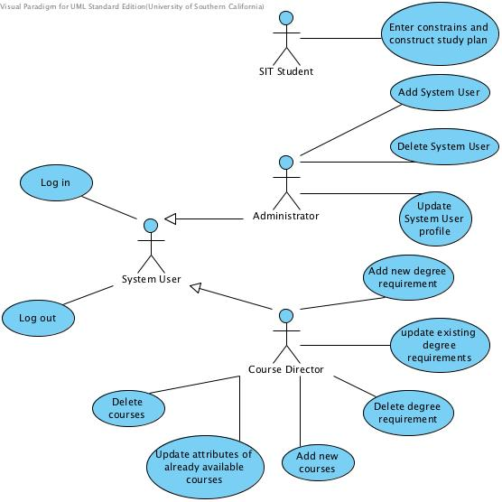
Figure 3: Process Diagram

Authentication

Log in
Table 3: Process Description
Identifier | UC-1: Log in
Purpose | WC_1533(Last Year):  Authorize the system user to log in the system and assign the system user associated system role.
Requirements | System must provide user privileges according his/her role (course director/ administrator).
Development Risks | None
Pre-conditions | Log in page is opened.
Post-conditions | Authorized system users get access to the system, and initial page will be shown. Unauthorized system users will be denied.
Table 4: Typical Course of Action
Seq# | Actor’s Action | System’s Response
1 | Enters a username and password on the login page.
2 | Clicks the “Sign in” button.
3 |  | System retrieves information associated with given username (role, password hash) form DB and checks password (password hash). Then it shows initial page according to the system user’s role.
Table 5: Exceptional Course of Action
Seq# | Actor’s Action | System’s Response
1 | Enters a username and password on the login page.
2 | Clicks the “Sign in” button.
3 |  | System retrieves information associated with given username (role, password hash) form DB and checks password (password hash). Check result is false.  Then system shows message: “Username or password is wrong. Please try again.”
4 |  | System shows log in page again.

There is no Alternate Courses of Action. Blank fields are treated as wrong username or password.

Log out
Table 6: Process Description
Identifier | UC-2: Log out
Purpose | WC_1533(Last Year):  Allow the user to log out the system.
Requirements | System user already has the privileges according his/her role (course director/ system administrator).
Development Risks | None.
Pre-conditions | User logged in the system. User can be on any page (accept login page, because user is already in the system); “Log out” link is available on every page.
Post-conditions | User’s session is closed, and log in page will be shown.

Table 7: Typical Course of Action
Seq# | Actor’s Action | System’s Response
1 | Clicks the “Sign out” button.
2 |  | System shows message that session was successfully closed, and then it shows log in page again.

There is no Exceptional or Alternate Courses of Action. Blank fields are treated as wrong username or password.

User management

Add user
Table 8: Process Description
Identifier | UC-3: Adding new user.
Purpose | WC_1533(Last Year):  Give the administrator ability to add new user in the system.
Requirements | System must provide user privileges according his/her role (student/course director/system administrator). User is on the initial page.
Development Risks | None.
Pre-conditions | User successfully entered the system as a system administrator. User is on initial page.
Post-conditions | One user profile is added to the system.
Table 9: Typical Course of Action
Seq# | Actor’s Action | System’s Response
1 | Clicks the button “Add new user”
2 |  | System shows empty user profile.
3 | Enters user’s name, login, role, and password.
4 | Clicks the button “Add”
5 |  | System checks correctness of the data. Data is correct. System adds new user and confirmation that user was added successfully.

Table 10: Exceptional Course of Action
Seq# | Actor’s Action | System’s Response
1-4 | Actions and responses are the same as in typical scenario.
5 |  | System checks correctness of the data. Data is incorrect (for example, username already exists). System shows appropriate message. System shows the same page.

There is no Alternate Course of Action.

Delete user
Table 11: Process Description
Identifier | UC-4: Delete user.
Purpose | WC_1533(Last Year):  Give the administrator ability to delete existing user from the system.
Requirements | System must provide user privileges according his/her role (student/course director/system administrator). User is on the initial page.
Development Risks | None.
Pre-conditions | User successfully entered the system as a system administrator.  System contains user for deletion. Edit user profile page is opened.
Post-conditions | One user profile is deleted from the system.
Table 12: Typical Course of Action
Seq# | Actor’s Action | System’s Response
1 | Presses the button “Delete user”
2 |  | System requests confirmation for deletion the user.
3 | Confirms deletion
4 |  | System deletes the user and shows confirmation that user was deleted successfully.  System redirects user to the initial page.

Table 13: Exceptional Course of Action
Seq# | Actor’s Action | System’s Response
1-3 | Actions and responses are the same as in typical scenario.
4 |  | The user cannot be deleted (DB is not accessible or user was not found). System shows appropriate message (ex. “DB is accessible” or “User was not found. Probably it was already deleted”)
There is no Alternate Courses of Action that have special processing.

Update user profile
Table 14: Process Description
Identifier | UC-5: Update user profile.
Purpose | WC_1533(Last Year):  Give the administrator ability to update existing user from the system (reset password, change name, and so on).
Requirements | System must provide user privileges according his/her role (student/course director/system administrator). User is on the initial page.
Development Risks | None.
Pre-conditions | User successfully entered the system as a system administrator.  System contains user for updating. . Edit user profile page is opened.
Post-conditions | One user profile is updated.
Table 15: Typical Course of Action
Seq# | Actor’s Action | System’s Response
1 | Updates fields (for example, name or new password) and press the button “Save”
2 |  | System checks correctness of the data. Data is correct. System updates user profile and confirmation that user was added successfully.
Table 16: Exceptional Course of Action
Seq# | Actor’s Action | System’s Response
1 | Actions and responses are the same as in typical scenario.
2 |  | System checks correctness of the data. Data it is incorrect (for example, username already exists). System shows appropriate message on the same page.
There is no Alternate Course of Action.

Study plan construction

Entering student defined constraints and study plan construction
Table 17: Process Description
Identifier | UC-6: Entering student defined constraints and study plan construction.
Purpose | Give the student a tool to specify his/her desires (degree, year of graduation, elective courses, and so on) and construct a study plan, which satisfies these constrains.
Requirements | WC_2658: The algorithm for generating the course schedule shall have guaranteed bounds on its execution time and/or bounds on optimality.  WC_2657: The system shall auto generate class/course schedule for undergraduate students given the following constraint: 1. Degree program requirements 2. Students desired courses related to his schedule  WC_2659: As a student, I can see which constraints need to be relaxed if the schedule is not generated in the fixed amount of time.  WC_2655: Better error explanation: 1. Prerequisites and corequisites error descriptions 2. Complex course requirements error description  WC_2654: Improve layout of course list of degree requirements on the student site.
Development Risks | Construction of the study plan may be algorithmically difficult.  User interface for specifying all the possible constrains is difficult to implement. It may require extra time.
Pre-conditions | User successfully entered the system as a student. User is on the Degree program selection page.
Post-conditions | Student got a study plan or notification that it is impossible to construct it.

Table 18: Typical Course of Action
Seq# | Actor’s Action | System’s Response
1 | Chooses degree and year (it is not a year of graduation; system will use degree requirements for this year)
2 |  | System shows list of requirements such as mandatory courses, electives that student may choose.
3 | Enters desired semester of graduation, coursed for which s/he has credits, desired electives, and presses the button ”Construct study plan”
4 |  | System makes an attempt to construct study plan. Study plan was found. The system shows the study plan.
Table 19: Alternate Course of Action
Seq# | Actor’s Action | System’s Response
1-3 | Actions and responses are the same as in typical scenario.
4 |  | System makes an attempt to construct study plan. It is impossible to construct study plan. The system shows a message “Unfortunately it is impossible to construct a study plan satisfying all the constraints. Try to relax constraints (for example, let the system choose elective courses) and repeat search again”.
5 |  | Then the system shows the page with the study plan constraints.

There is no Exceptional Courses of Action.

Entering and modification of the degree requirements

Add new requirement

Table 20: Process Description
Identifier | UC-7: Adding new requirement
Purpose | Give the course director a tool to specify new degree requirement.
Requirements | WC_1350(Last Year): Administrator can input degree requirements for each year of entry and degree combinations.  WC_1329(Last Year): As an administrator I must be able to enter degree requirements as complex as those that have been in effect, for the CS, IS, and CyS undergrad degrees and are listed, on the Stevens CS dept. website as well as additional clarifying details provided by the client to the team.
Development Risks | Construction of the study plan may be algorithmically difficult.  User interface for specifying all the possible constrains is difficult to implement. It may require extra time.
Pre-conditions | User successfully entered the system as a course director. User is on Add new requirement page.
Post-conditions | Updated degree requirements.

Table 21: Typical Course of Action
Seq# | Actor’s Action | System’s Response
1 | Chooses requirement type from the available list of types
2 |  | System shows parameters which must be specified for the requirement.  (For example, if type is “Select n courses from the list” we need to specify n and the list of the courses. If it is a composition of other requirements then user need to choose other requirements)
3 | Specifies necessary parameters and press the button “Add”
4 |  | System checks correctness of the data. Data is correct. The system updates requirement and shows confirmation that new requirement was added successfully.

Table 22: Exceptional Course of Action
Seq# | Actor’s Action | System’s Response
1-3 | Actions and responses are the same as in typical scenario.
4 |  | System checks correctness of the data. Data it is incorrect (for example, not all fields are field in). The system shows appropriate message on the same page.

There is no Alternate Courses of Action.

Update requirement
Table 23: Process Description
Identifier | UC-8: Updating the requirement
Purpose | Give the course director a tool to change existing degree requirement.
Requirements | WC_1350(Last Year): Administrator can input degree requirements for each year of entry and degree combinations.  WC_1329(Last Year): As an administrator I must be able to enter degree requirements as complex as those that have been in effect, for the CS, IS, and CyS undergrad degrees and are listed, on the Stevens CS dept. website as well as additional clarifying details provided by the client to the team.
Development Risks | Construction of the study plan may be algorithmically difficult.  User interface for specifying all the possible constrains is difficult to implement. It may require extra time.
Pre-conditions | User successfully entered the system as a course director.  User is on Edit requirement page.
Post-conditions | Updated degree requirements.
Table 24: Typical Course of Action
Seq# | Actor’s Action | System’s Response
1 | Updates requirement’s parameters and presses the button “Save”
2 |  | System checks correctness of the data. Data is correct; system updates user profile and shows confirmation that the requirement was updated successfully.
Table 25: Exceptional Course of Action
Seq# | Actor’s Action | System’s Response
1 | Actions and responses are the same as in typical scenario.
2 |  | System checks correctness of the data. Data is incorrect (for example, not all fields are field in) system shows appropriate message on the same page.

There is no Alternate Courses of Action.

Delete requirement
Table 26: Process Description
Identifier | UC-9: Delete the requirement
Purpose | Give the course director a tool to delete existing degree requirement.
Requirements | WC_1350(Last Year): Administrator can input degree requirements for each year of entry and degree combinations.  WC_1329(Last Year): As an administrator I must be able to enter degree requirements as complex as those that have been in effect, for the CS, IS, and CyS undergrad degrees and are listed, on the Stevens CS dept. website as well as additional clarifying details provided by the client to the team.
Development Risks | Construction of the study plan may be algorithmically difficult.  User interface for specifying all the possible constrains is difficult to implement. It may require extra time.
Pre-conditions | User successfully entered the system as a course director.  User is on Edit requirement page.
Post-conditions | Deleted degree requirements.
Table 27: Typical Course of Action
Seq# | Actor’s Action | System’s Response
1 | Delete requirement’s parameters and presses the button “Yes”
2 |  | System checks correctness of the data. Data is correct; system updates user profile and shows confirmation that the requirement was deleted successfully.
Table 28: Exceptional Course of Action
Seq# | Actor’s Action | System’s Response
1 | Actions and responses are the same as in typical scenario.
2 |  | System checks correctness of the data. Data is incorrect (for example, the requirement can’t be deleted) system shows appropriate message on the same page.

There is no Alternate Courses of Action.

Add new course
Table 29: Process Description
Identifier | UC-10: Adding new course in the system.
Purpose | WC_1349(Last Year): Give the course director a tool to change existing degree requirement.
Requirements | Administrator can input information about individual courses.
Development Risks | None.
Pre-conditions | User successfully entered the system as a course director.  User is on Add new course page.
Post-conditions | Updated list of the available courses.
Table 30: Typical Course of Action
Seq# | Actor’s Action | System’s Response
1 | Enters course attributes such as name, number of credits, type and presses the button “Save”
2 |  | System checks correctness of the data. Data is correct; system updates user profile and shows confirmation that the requirement was added successfully.

Table 31: Exceptional Course of Action
Seq# | Actor’s Action | System’s Response
1 | Actions and responses are the same as in typical scenario.
2 |  | System checks correctness of the data. Data is incorrect (for example, not all fields are field in); system shows appropriate message on the same page.
There is no Alternate Courses of Action.

Update the course
Table 32: Process Description
Identifier | UC-11: Updating the course attributes in the system.
Purpose | WC_1349(Last Year): Give the course director a tool to change existing degree requirement.
Requirements | Administrator can input information about individual courses.
Development Risks | None.
Pre-conditions | User successfully entered the system as a course director.  User is on Edit course page.
Post-conditions | Updated list of the available courses.
Table 33: Typical Course of Action
Seq# | Actor’s Action | System’s Response
1 | Updates course attributes such as name, number of credits, type and presses the button “Save”
2 |  | System checks correctness of the data. Data is correct; system updates user profile and shows confirmation that the requirement was updated successfully.
Table 34: Exceptional Course of Action
Seq# | Actor’s Action | System’s Response
1 | Actions and responses are the same as in typical scenario.
2 |  | System checks correctness of the data. Data is incorrect (for example, not all fields are field in); system shows appropriate message on the same page.
There is no Alternate Courses of Action.

Delete a course
Table 35: Process Description
Identifier | UC-12: Deleting a course in the system.
Purpose | Give the course director a tool to delete existing courses.
Requirements | WC_1349(Last Year): Administrator can input information about individual courses.
Development Risks | None.
Pre-conditions | User successfully entered the system as a course director.  User is on Delete course page.
Post-conditions | Updated list of the available courses.
Table 36: Typical Course of Action
Seq# | Actor’s Action | System’s Response
1 | Choose the course and presses the button “Delete”
2 |  | System checks correctness of the data. Data is correct; system updates user profile and shows confirmation that the course was deleted successfully.
Table 37: Exceptional Course of Action
Seq# | Actor’s Action | System’s Response
1 | Actions and responses are the same as in typical scenario.
2 |  | System checks correctness of the data. Data is incorrect (for example, not all fields are field in); system shows appropriate message on the same page.
There is no Alternate Courses of Action.

Modes of Operation
The Student Scheduling System operates only in one mode.

System Analysis Rationale
For our project, the most challengeable part is the algorithm. Generating a valid study plan based on student’s specific desires is the main goal of our system. However, preliminary analysis done by last semester team shows that finding a satisfactory study plan in Student Scheduling System is typical combinatorial optimization problem, which is an NP-hard problem. In order to improve the efficiency of the algorithm developed by last year team, we came up with a way to separate the whole computing process into several steps, since it is really important to be sure that the system is able to find a solution in a reasonable time.
Another interesting aspect of the system is the data structure representing the degree requirements(prerequisites & co-requisites). As it was mention before Stevens, degree requirements are combine a wide range of different requirements of high complexity. For this reason, building a reasonable and suitable data structure is quite important. As shown below, we picked a modified DAG to be the data structure.
The process of this analysis includes the following steps:
- Identification of degree requirement types (informal description)
- Identification of possible student defined constraints (informal description)
- Building data structure (DAG) for degree programs (data structure modeling)
- Developing test case which covers most of the constraints (description of degree requirements for one degree and description of student desires for study plan).
- Refining UI prototype for the test case.
- Developing test program for finding study plan.
These steps allow getting feedback from the client as soon as possible and mitigating risks associated with constraint solving complexity.

Technology-Independent Model
Since we need to satisfy technology-dependent requirements defined by client stakeholders (otherwise they will not be able to maintain the system), this section is skipped. Moreover, we already know technology-specific details of the system design; therefore, this section is intentionally omitted.

Technology-Specific System Design
The following diagram (Figure 3) shows the Hardware structure. The web/application /DBMS server will be connected with client workstations through the Internet Network. This is a typical web application in MVC.

Design Overview

System Structure
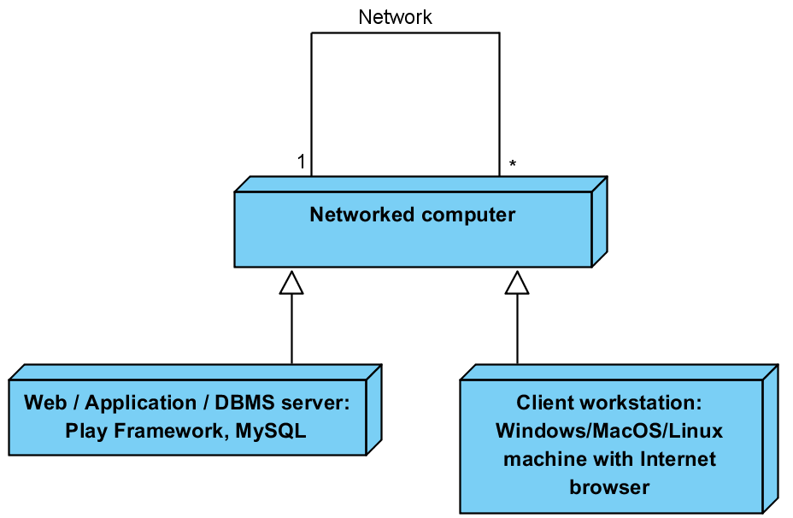
Figure 4: Hardware Component Class Diagram
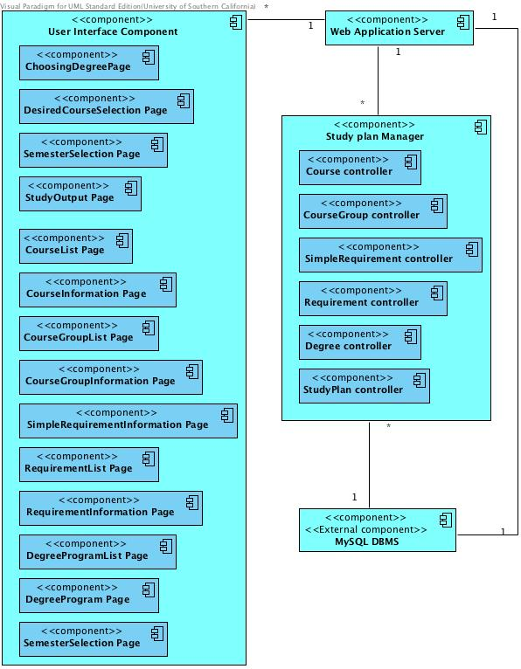
Figure 5: Software Component Class Diagram

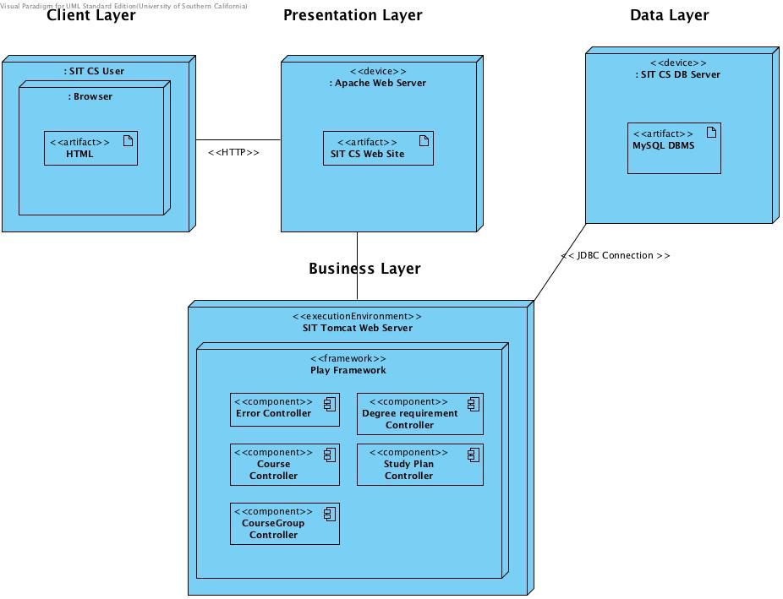
Figure 6: Deployment Diagram

Table 38: Hardware Component Description
Hardware Component | Description
Web/Application/DBMS Server | This component accepts connections from all users.  Web and Application server are provided by Play framework.  Since data base is comparatively small and does not require high-performance hardware it was decided to host with Web and Application server.
Client workstation | This is a user computer. It must have a web browser (Mozilla Firefox) and it must have Internet network.

Table 39: Software Component Description
Software Component | Description
User interface component | This component contains all the webpages of the system.
Study plan manager | This component contains controller for study plan construction webpage and classes that performs prerequisites and corequisites checker and constraint solver, then output final study plan.
Web/Application Server | This component is the web/application server in Stevens Institute Technology.
MySQL DB server | Data base that stores all entities of the system. This is data layer of the system.

Design Classes
The design classes describe the relationships among the boundary, control, and entity classes of the Student Scheduling System.

Frontend class Diagram
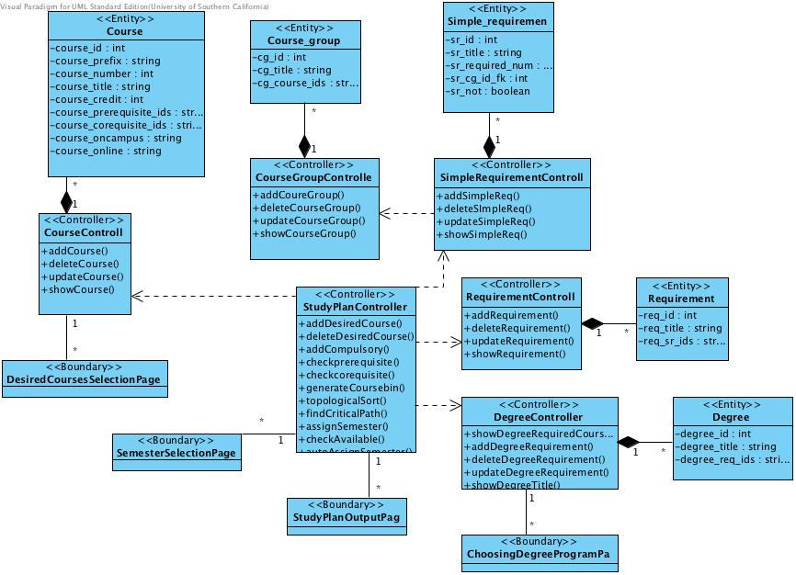
Figure 7: Frontend Class Diagram
Table 40: Front End Classes Description
Class | Type | Description
ChossingDegreeProgramPage | Boundary | This webpage allows student to choose  degree program for study plan
DesiredCoursesSelectionPage | Boundary | This webpage allows student to choose  Desired courses for study plan
SemesterSlectionPage | Boundary | This webpage allows student to specify  number of semesters in study plan, all  preferred courses, courses that were  already taken, and other constraints
StudyPlanOutputPage | Boundary | This webpage shows student study plan  if it was found
Course | Entity | Course information: prefix, number, title, credit, prerequisites, corequisites, oncampus, online.
Semester | Entity | Semester information: year, name
Course_group | Entity | Course group information: title, correspongding courses
Simple_requirement | Entity | Simple requirement information: title, required course number, corresponding course group
Requirement | Entity | Requirement information: title, corresponding simple requirement
Degree | Entity | Degree information: title, corresponding requirement.
CourseController | Controller | This component implements all CRUD operations over courses.
SemesterController | Controller | This component implements all CRUD operations over semesters.
CourseGroupController | Controller | This component implements all CRUD operations over course groups.
SimpleRequirementController | Controller | This component implements all CRUD operations over simple requirements.
RequirementController | Controller | This component implements all CRUD operations over requirements.
DegreeController | Controller | This component implements all CRUD  operations over degree programs
StudyPlanController | Controller | This component performs prerequisites and corequisites checker and constraint solver, then output final study plan .

Backend class diagram
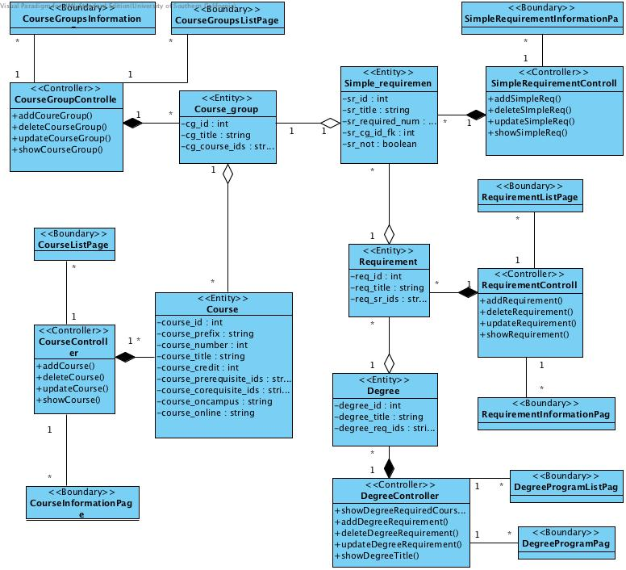
Figure 8: Backend Class Diagram`

Table 41: Backend Class Description
Class | Type | Description
CourseListPage | Boundary | On this webpage course director can see all courses created in the system and choose create/edit/delete operation.
CourseInformationPage | Boundary | On this webpage course director can update or create course information.
CourseGroupListPage | Boundary | On this webpage course director can see all course groups created in the system and choose add/edit/delete operation.
CourseGroupInformationPage | Boundary | On this webpage course director can update or create course group information.
SimpleRequirementInformationPage | Boundary | On this webpage course director can update or create simple requirement information.
RequirementListPage | Boundary | On this webpage course director can see all requirements created in the system and choose add/edit/delete operation.
RequirementInformationPage | Boundary | On this webpage course director can update or create requirement information.
DegreeProgramListPage | Boundary | On this webpage course director can see all degree programs created in the system and choose add/edit/delete operation.
DegreeProgramPage | Boundary | On this webpage course director can update or create degree program information.
SemesterSelectionPage | Boundary | On this webpage course director can choose semester to get information of corresponding degree program.

Process Realization
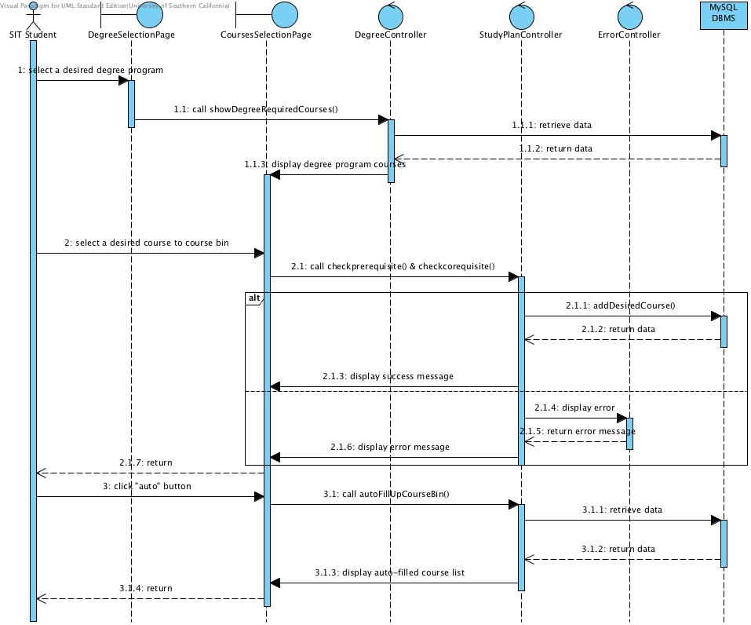
Figure 9: Select Desired Course Sequence Diagram
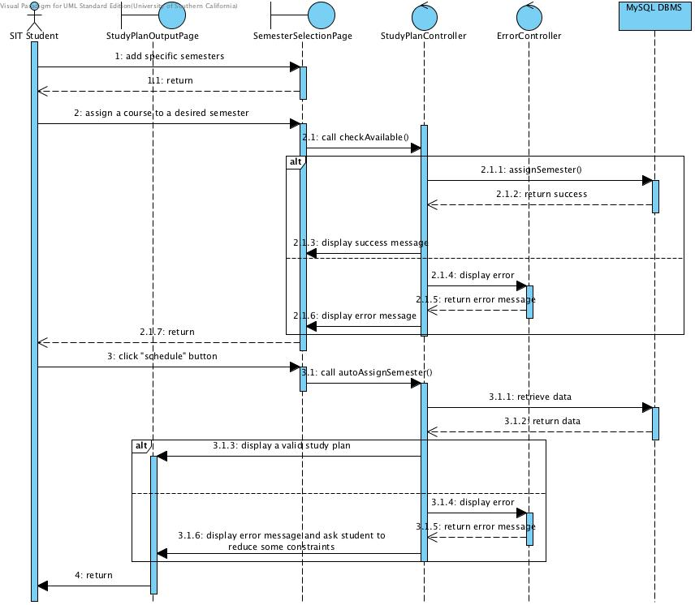
Figure 10: Assign Courses to Semesters Sequence Diagram

Design Rationale
In order to make Student Scheduling System used by Stevens University students and staff, it must be accessible via the Internet for all users. Therefore, Student Scheduling System is designed as a web application.
In database design, to make CRUD of degree program more efficient and convenient, we construct the degree course DAG into the database. To make the study plan construction even more efficient, we store frequently used study plan in the database.
To make system more flexible and open to future changes three-tier architecture pattern was chosen. This pattern allows us to separate three layers of the system:
  - User interface (web pages)
  - Business logic (controls that implement study plan construction and other use cases)
  - Data layer (date base, which store persistent information).
In order to make application simpler and more service oriented we chose REST architecture style for interaction with the system. Play framework for java was chosen as one of the most convenient frameworks for web application development that supports REST style. Another reason to choose Play framework is that it already has secure module, which enable us to set up basic authentication and authorization management to our application.
For persistence layer we chose MySQL DBMS because it’s one of the most wide-used open source DBMS. Moreover, it is easy to integrate it with Play framework; they are absolutely compatible.

